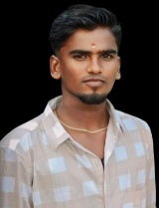

S.ELAMARAN

BSc Computer Science

Enathi rajappa College,

enathi
About

- Education

- Skills

About Me
I'm a student of enathi rajappa College, enathi . I'm currently studying in II BSc CS class. I'm also committed to helping others learn more about the importance of education.

Education
Bharathidasan University - BSc in Computer Science

Skills
- PHP
- Python
- Java
- Ruby
- Sql
© 2025 S.Harish

